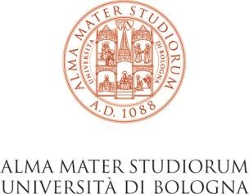

GrEnFin QF Fridays with the industry
GrEnFIn and QF meet people from the industry to give you advice and for possible recruiting. In the QF special days quants and managers will present their company and will take away you or your cv!

Monday, May 20th, 2024
Online via Microsoft Teams - h 11:00 am – 13:00 am
SINLOC meets GrEnFIn and QF

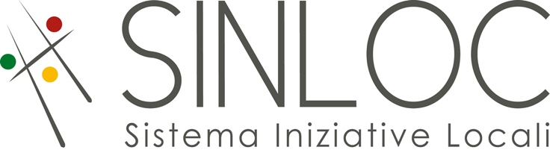
Marina Mazzanti Gabriela Rios Andreghetti
HR Management and Development Manager HR Specialist

Matteo Meneghetti Alessandra Montanelli
Consultant Senior Consultant

ABOUT SINLOC

SINLOC GROUP

Sinloc is a group which unites project companies that implement and manage Public Private Partnership (PPP) initiatives and instrumental subsidiaries that concentrate on particular market areas.
The instrumental subsidiaries carry out consultancy activities in complementary sectors compared to those supervised by the parent company, Sinloc S.p.A., such as credit mediation, impact assessments, energy communities and decarbonization, public funding implementation, and food and health strategies.
Thanks to the synergy, expertise and resources developed by our employees, Sinloc provides its customers with consistent integrated and innovative solutions.

SINLOC S.p.A.

Sinloc S.p.A. is a consulting and investment company that promotes local development mostly through the implementation of infrastructures, with technical assistance activities, feasibility studies and investments in Public-Private Partnership projects all over Italy and Europe. Furthermore, it supports local institutions, companies, and non-profit entities in setting up projects, also by searching for necessary national and European funds. The projects of Sinloc S.p.A. focus mainly on 8 areas of activity: energy transition, urban regeneration, mobility and logistics, networks and public utilities, healthcare and welfare, education and research, art and tourism and food and health. Sinloc S.p.A. is the parent company of Sinloc, a group that has developed direct responsibility towards investors and communities of reference, consistently with the seventeen Sustainable Development Goals of the United Nations.

Be there or be square!

